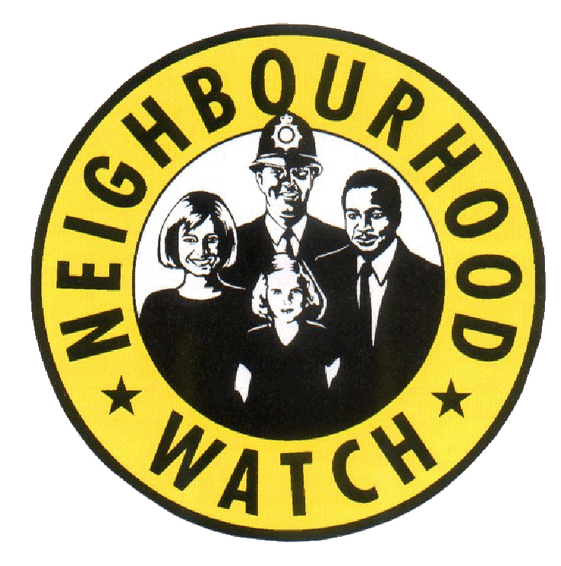

EAST RIDING NEIGHBOURHOOD WATCH
April/May 2019

Dear Coordinators

Firstly I would also like to say thank you and welcome to the new groups that have signed up so far this year;

South Cave Castle Drive, Bridlington Abbotts Way, Bridlington Milner Road, Bridlington Holyrood Avenue, Withernsea Seacroft Road, Withernsea Southfield Avenue, Beverley Sylvester Court, Burton Pidsea Glebelands Hessle Westbourne Grove/Avenue and Circle, Hessle Barrow Lane/Mount/Pulcroft, Hessle Westfield Rise Swanland, Bridlington Trinity Road, , Bridlington Cleeton Way Hessle Town Council, Wressle Parish Council, Holme on Spalding Moor Parish Council, Goodmanham Parish Council, East Cottingwith and Storwood Parish Council, Halsham Parish Council, Beverley, Whitefields Close Bridlington Thornton Grove, Bridlington Harrington Road, Ellerton and Aughton Village Parish Council, Foggathorpe Village Parish Council, Beverley Friars Lane, Bubwith Village Parish Council, Bridlington Aysgarth Rise.

Training:

We now have nearly 400 NHW groups across the East Riding and that is fantastic. However, over the next 12 months I would like to look at developing training needs for both new and existing coordinators. You may be interested in a Friends of Scams / Scam Awareness course or want to be more informed about Child Exploitation. You may also benefit from very basic support on how to set up a Neighbourhood Watch email address and a contacts list. Whatever it is, I would like to know.

Please contact me with the name of your NHW Group, which town/village it is in and what training you would like to see provided.

East Riding of Yorkshire Council Child Exploitation Advisor Helen Jones-Brown recently held a Child Exploitation Workshop for Coordinators in and around Bridlington. We would like to offer this to more East Riding coordinators who would be interested. Please register your interest with me.

The workshop will include the following aims:

- To gain an understanding of Child Exploitation including criminal and sexual
- Provide an overview of the local, regional and national approach to Child Exploitation
- Examples of family experiences of Child Exploitation
- Facilitated discussion around what action is/or can be delivered locally to improve responses to children and young people at risk of harm through sexual abuse and exploitation.

Neighbourhood Watch Networking Event 2019:

For those of you who were able to attend, we know by the feedback we have received that you all found it an enjoyable and informative morning. As you know the theme for this year was Anti-Social Behaviour (ASB) – What it is and how East Riding of Yorkshire Council and Humberside Police work together to tackle it.

Following presentations from the Anti-Social Behaviour Team, Youth and Family Support Team and Humberside Police, we asked those who attended to take part in a workshop where coordinators from across the county worked together and discussed the following:

- How can you help the Anti-Social Behaviour Team tackle ASB?
- How can NHW Coordinators help residents tackle ASB?

We have put together a pack of the presentations and information/feedback from the event which includes:

- Presentations from the Anti-Social Behaviour Team, the Youth and Family Support Team and Humberside Police
- The Anti-Social Behaviour Team Boundary Map
- The feedback provided by coordinators during the workshop in response to the questions

Please email me to order a pack.

The feedback we received from the workshop is really important and useful to us. We want to share this with the local police teams and incorporate your suggestions into an action plan and timetable of events that you can get involved with to help us tackle ASB over the next 12 months.

We set the theme of each event to address current issues. For next year’s event we would like you to have a say in what that might be. Please let me have your suggestions by 1st September 2019.

Regular Features

CRIMESTOPPERS:
While improvements are being made to the non-emergency number please use Crime stoppers to report criminal activity on 0800 555 111. However, if you require urgent police attention call 999.

MY COMMUNITY ALERT:

Sign up to the new free messaging system operated by Humberside Police and keep updated with what is happening in your local area. For more information and to register go to

www.mycommunityalert.co.uk

CRIME PREVENTION SHOP:

A reminder that Hull Neighbourhood Networks have an on line shop where you can buy all sorts of crime prevention items.
Here’s the link
https://www.nnetwork.org.uk/shop/

There are a number of items available including card protectors which will stop fraud by blocking access to the magnetic strip on your card which if accessed can result in your card details being duplicated.
we sell them at a £1.00 each!

The coupon code is ERMEMBER so that the groups in the East Riding can get the discount. Just add the coupon code when prompted and the discount will be taken off,
The current discount is £1.00 per item and currently £5.00 off the cycle lock. We have set up postage with Hermes but they can offer collection from their base at Zeal’s Garth Hull free of charge.

The next NHW Newsletter will be sent out at the end of July/ beginning of August so the deadline for coordinator contributions will be Monday 29th July 2019.

Maureen Yates Community and Crime Reduction Resilience Officer
Housing and Public Protection, East Riding of Yorkshire Council, County Hall, Cross Street, Beverley
HU17 9BA
Telephone: 01482 391013
Mobile: 07899 061213
Maureen.yates@eastriding.gcsx.gov.uk

