Bridlington update for April 2019

- CRIME AND ASB

Bridlington North

Bridlington Central and Old Town

Bridlington South

TFMV - Theft from motor vehicle / TOMV - Theft of motor vehicle / ASB - Anti-social behaviour
I note with pleasure a reduction in Burglary across all ward areas here in Bridlington. This category includes “Burglary Other” which could be a shed or garage burglary. This reduction has been achieved by a multi-pronged approach of targeting persistent offenders, increasing knowledge of crime prevention techniques and may be attributable to the increase in Neighbourhood Watch groups in the town as they are now sharing information with their local Pcso and intelligence is being submitted. The reporting of more suspicious activity via the 101/999 enabling officers to attend more quickly.

Christopher Neighbourhood Policing Sergeant

- Crime and Issues of particular note

There is an increase in Drug Offences across Central and Old Town and Bridlington South. This is explained by the excellent work our Officers are undertaking in using their powers to Stop and Search those suspected of carrying drugs and the execution of warrants at premises. Often successes are prompted by the use of intelligence that has been shared with us from members of the community and there are numerous ways to do this. You could ring 101, speak with an Officer, attend the Police Station, e-mail us at www.humberside.police.uk or ring or e-mail Crimestoppers on 0800555111 and www.crimestoppers-uk.org all information s treated in the strictest confidence and you can remain anonymous.

- Community Priorities

Disruption of Drug activity – We are continuing to tackle the issue of drug dealing in the town with operations planned and ongoing, as well as the daily task of Officers using their powers of Stop and Search. Used appropriately, this is a great way of quickly removing drugs from the street and disrupting the activity of those involved.

Humbertalking – We have been pounding the streets twice weekly to survey hundreds of homes in the area to find out what your thoughts are on what you think we should be concentrating our efforts on. I am sure the final results will make interesting reading and will undoubtedly shape what we do in your area in the future. In order to participate in the survey please go to www.mycommunityalert.co.uk/humbertalking

Anti-Social Behaviour – The majority of incidents we attend as a Neighbourhood Team are categorised as Anti-social behaviour (ASB). This can be further split into Nuisance, Personal and Environmental. As the largest area of our business this will be a priority. We will continue to engage the public and attend incidents and situations that need to be addressed, this could be anything from nuisance youths to behaviour that falls short of being a crime.

- Crime Reduction Advice

Groups such as The Bridlington Central Action Group who hold meetings every second Tuesday in the month enable the Community in the Town Centre to attend and share any concerns or issues within their area.
Neighbourhood Watch (NHW) is now more pro-active in the Bridlington area, working with Maureen YATES from ERYC to promote and publicise NHW in the Town by recruiting more co-ordinators and assisting the Police by attending Surgery’s within the Town.
If you are interested in setting up a group please contact Maureen on Maureen.Yates@eastriding.gcsx.gov.uk
Social Media has also been a great help for the Community to Share information.

- Meet your officers –

Officers attend Police surgery meetings in your area on a regular basis and will be pleased to meet you to discuss any issues.

To find meetings in your area please visit our website at www.humberside.police.uk. On the home page click on the ‘Find My Neighbourhood Policing Team’ button. Click on your area within the map and then press the ‘Go To Team Page’ button. At the bottom of the page you will see a list of meetings.

- News and Appeals

Please visit our website www.humberside.police.uk for the latest news & appeals, and find out more about My Community Alert.

“My Community Alert” is a free messaging system operated by Humberside Police and Humberside Fire & Rescue Service, giving you live information about incidents happening in your area. Choose how you receive messages, by either phone or email, how often you want to hear from us and about the issues that matter to you. When something happens that you’ve told us you want to hear about, your local officer will send you the details, whether that’s notice of a road closure due to a collision or a burglar who has been caught in a nearby garden. Subscribe to My Community Alert to be the first to know about issues that might affect you or your family. Sign up for free on mycommunityaltert.co.uk to start receiving real time updates now.

- Useful information

Importance of Reporting incidents/crimes

Just a reminder that it is really important you report any crimes or suspicious incidents to us. This can be either via 999 or the 101 phone number, via our web site, or personally at a police station or to an officer in the street. Only by reporting the crime/incident can we be aware of it. Once we are aware we may not be able to do anything about it immediately but the report will form part of a wider picture which helps inform where we direct officers to patrol and focus activity. So please ….. take the time to report a crime/incident in the knowledge your time is not wasted. www.humberside.police.uk

The Neighbourhood Policing Team meet regularly with partners to ensure we have a multi- agency approach to local issues, individuals and problem solving. These meetings are regularly attended by partners including Humberside Fire and Rescue Service, Youth and Family Support, Housing Officers, Environmental Health and the East Riding Anti-Social Behaviour Team. We share information and resources to deal with local neighbourhood issues, in particular, those identified as causing the most harm in the community.

National Crime Statistics - Please look at this link to https://www.police.uk
Click on ‘Find Your Neighbourhood’ and input a post code. You can interrogate the data and get some quite specific crime information. Please be aware that the data can be a month or 2 behind.

Also follow us on www.twitter.com/HP_BridDrifHorn

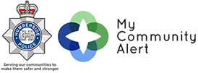

Also follow us on www.twitter.com/HP_BridDrifHorn

AREA COVERED BY BRIDLINGTON CENTRAL AND OLD TOWN WARD

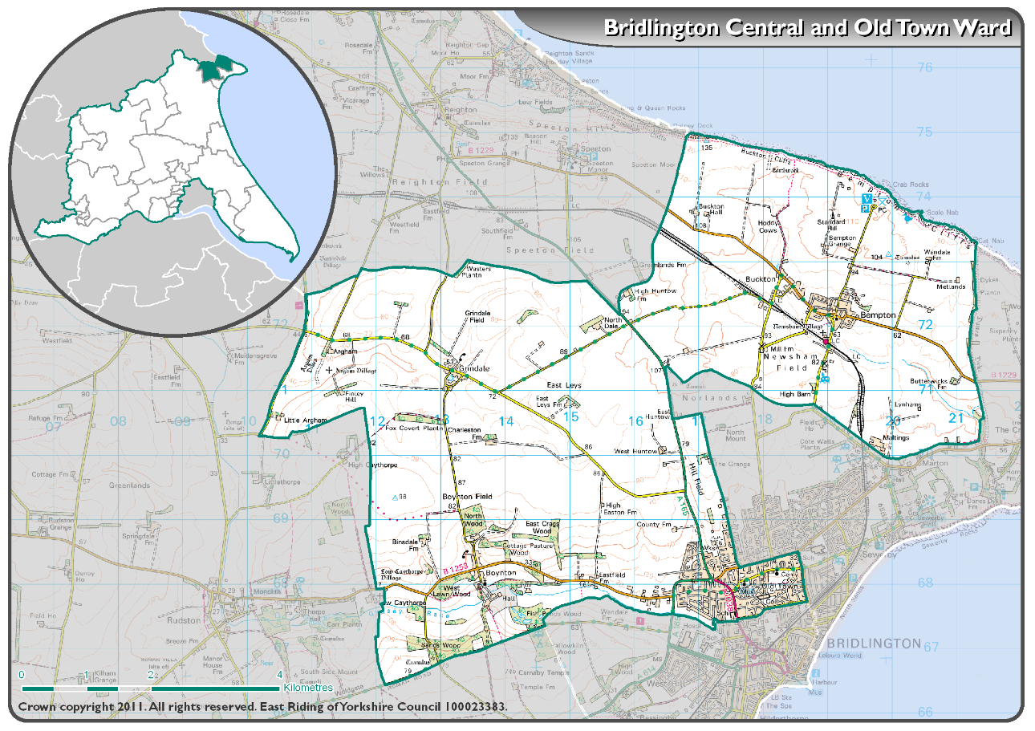

AREA COVERED BY BRIDLINGTON NORTH WARD

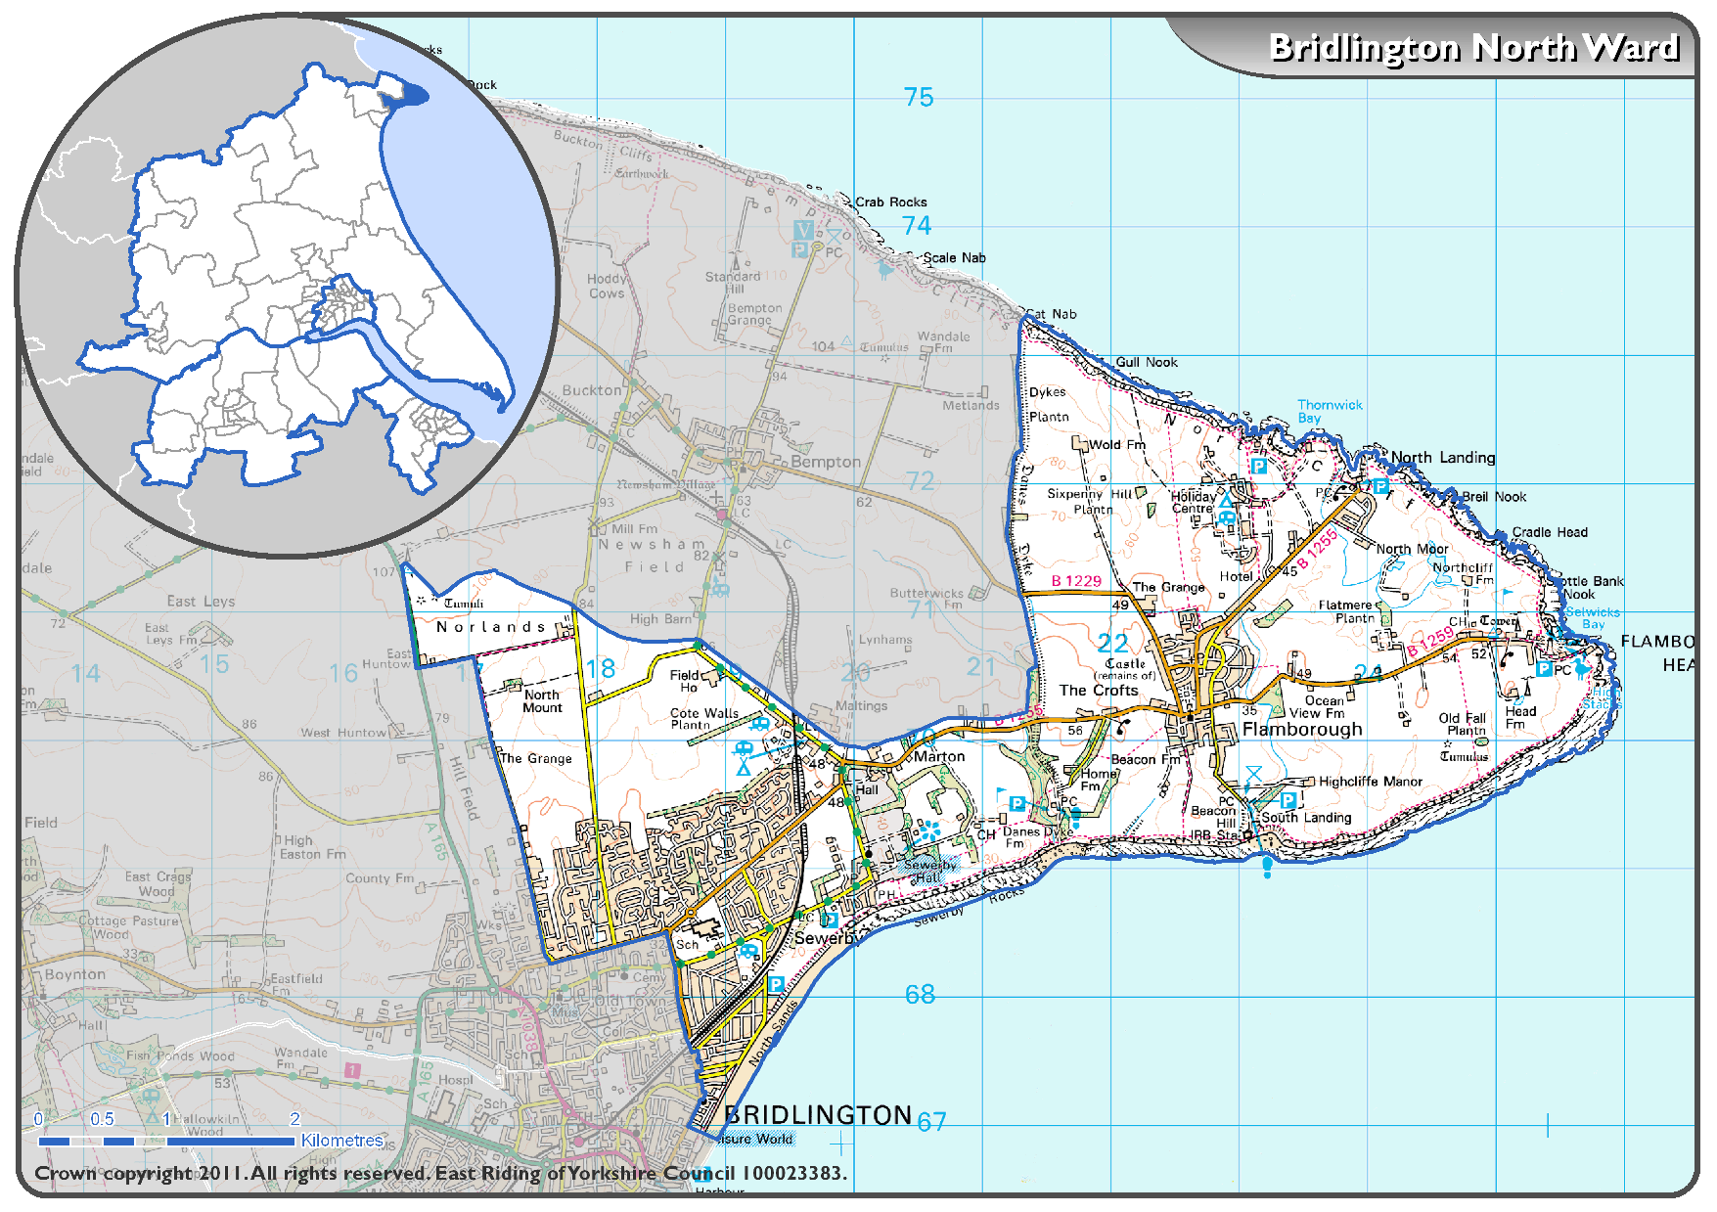

AREA COVERED BY BRIDLINGTON SOUTH WARD

