Bridlington update for July 2019

- CRIME AND ASB

Bridlington North

Bridlington Central and Old Town

Bridlington South

TFMV - Theft from motor vehicle / TOMV - Theft of motor vehicle / ASB - Anti-social behaviour

- Crime and Issues of particular note

On 29/07/19 officers from the Neighbourhood Team conducted patrols in relation to drug misuse around the town centre of Bridlington. As a result a male juvenile was arrested for drug supply offences and drugs recovered. The Neighbourhood Team would like to re-assure the community that positive action will be taken to disrupt and prosecute those involved in drug misuse around the town.

A number of beach chalets were broken into during the early hours of Friday 26th July on South Beach in Bridlington. With the assistance of Civic CCTV, two juveniles were arrested nearby for the offence. Owners of chalets are reminded not to leave items of value within the chalets, ensure they are adequately secured and to consider the benefit of registering anything left within the chalets with URN’s on immbolise.com.

Overnight between 30/07/19 and 31/07/19 a garage burglary has occurred on Bempton Lane, Bridlington where three bicycles were stolen.
If anyone has witnessed the incident or any suspicious activity during the evening please can they contact police on 101 quoting Investigation 16/87461/19.

Please can all residents with garages and outbuildings consider target hardening their properties with good locks and consideration of security lighting and CCTV. Should any items of value be secured within outbuildings please visit the website www.immobilise.com to register items in particular cycles where photographs and unique reference numbers can be uploaded.

- What’s Happening In Your Area?

Disruption of Drug activity – We continue to tackle the issue of drug dealing in the town with operations planned and ongoing, as well as the daily task of Officers using their powers of Stop and Search. Used appropriately, this is a great way of quickly removing drugs from the street and disrupting the activity of those involved.

Commercial Burglary – There has been an increase in commercial Burglaries in all areas of Bridlington. These are taking place overnight with cash being stolen. Businesses are reminded to remove cash from premises and consider a sign indicating that no cash is left in the premises overnight. A review of general security should also be considered. Officers will be tasked to patrol vulnerable areas.

Anti-Social Behaviour – The majority of incidents we attend as a Neighbourhood Team are categorised as Anti-social behaviour (ASB). This can be further split into Nuisance, Personal and Environmental. As the largest area of our business this will be a priority. We will continue to engage the public and attend incidents and situations that need to be addressed, this could be anything from nuisance youths to behaviour that falls short of being a crime.
- Crime Reduction Advice

OP AZTEC

We’re taking part in the national firearms surrender from 20 Jul – 4 Aug, encouraging unwanted and imitation firearms to be surrendered. In 2017, 199 real or imitation firearms were surrendered. Although the amnesty will likely be over when this Newsletter is circulated we would still encourage members of the public to surrender firearms so that they are taken out of circulation.

Due to this being holiday season we would like to repeat advice on how to protect your home while you are on holiday. The main message is to not to leave your house looking unoccupied

• Mow the lawn before you leave so that it doesn’t look like a meadow by the time you get back.
• Leave curtains and blinds open – nothing reveals that a house is unoccupied so much as curtains drawn during the day.
• Cancel milk and newspapers and any other regular deliveries.
• Ask a neighbour to remove free newspapers and post from your doormat if they can be seen through a glass panel or through the letterbox.
• Install a light on a timer switch that comes on in the evening. If you are using a light on a timer, don’t use it with a table lamp that can be viewed through a window – a dead giveaway.

Keep your valuables safe

• Keep valuables out of sight and don’t leave them where they can be seen through a window.
• If you conceal valuables in your home, avoid obvious hiding places such as your sock drawer or in a fake food can in the kitchen – burglars are wise to this trick.
• Try not to leave anything you would hate to lose in the house while you are away
• Given that most burglars are opportunists and their motive is generally to get in, get something of value and then get out as fast as possible, your intruder might be encouraged to leave after finding a fake hoard rather than turning your house upside down to find anything of real value.

Don't tell everyone you're on holiday

• Don’t tell people outside immediate friends and family that you are going away or for how long.
• Don’t talk about your planned holiday on social media - you don’t know who can read your comments, or who they will tell.

Neighbourhood Watch (NHW) is now more pro-active in the Bridlington area, working with Maureen YATES from ERYC to promote and publicise NHW in the Town by recruiting more co-ordinators and assisting the Police by attending Surgery’s within the Town.
If you are interested in setting up a group please contact Maureen on Maureen.Yates@eastriding.gcsx.gov.uk
Social Media has also been a great help for the Community to Share information.

- Meet your officers –

Officers attend Police surgery meetings in your area on a regular basis and will be pleased to meet you to discuss any issues.

To find meetings in your area please visit our website at www.humberside.police.uk. On the home page click on the ‘Find My Neighbourhood Policing Team’ button. Click on your area within the maps. At the bottom of the page you will see a list of meetings.

- News and Appeals

If you’re a victim of domestic abuse - don’t suffer in silence – no matter where you live.

A report published by the National Rural Crime Network (NRCN) has found that many victims of domestic abuse in more rural communities suffer for longer before asking for help.
However, Superintendent Tracy Bradley from our Force Control Room is today urging anyone experiencing domestic abuse to get in touch.
She said: “Our force area has a large rural community and we know that there will be victims out there who have not yet found the courage to come and seek help.
“We want to send a message to you that we will listen and we will act. No one needs to fear from coming to the police to report domestic abuse.
“Tackling domestic abuse is our top priority. If you are a victim of domestic abuse or are in a controlling relationship, or you know someone who is - please call us on 101 or in an emergency 999. We will listen, we will act, we will help you.
“We have a dedicated team of experts who deal with domestic abuse. These officers know how difficult reporting it can be and they will ensure that you are safe when you report it and throughout any police or court action that may follow.”

“We know how difficult that first call might seem but the call handlers are trained to deal with your situation and will always be sympathetic and understanding.
“No one needs to suffer in silence. All victims are spoken with without prejudice and in confidence - if you are male or female you can come to us in complete confidence.
“We don’t do this alone and work with other people can work with us to plan a way forward that works for you and your family.
“We are constantly looking at ways to continuously improve our response to victims of domestic abuse. We work with others for feedback on issues with the current process and importantly ideas on how we could improve things going forward.
“All of this work means that no matter who you are or where you are we can help you and we will pursue and bring to justice people who commit domestic abuse and coercive control.”
We have lots more information about what domestic abuse is and how to report it on our website https://www.humberside.police.uk/DA
Read more about the NRCN report here: https://www.ruralabuse.co.uk/
Good News

Leeds man charged with Bridlington Robbery - 15 Jul 2019

Incident at the Skate Park, Northfield in Bridlington.

A 14 year-old boy was allegedly threatened with a knife and robbed of £5 as he played in the Skate Park at Bridlington at 8.30pm on Saturday 13 July.

Officers were in the area at the time of the robbery and three suspects (a man and two youths) were quickly apprehended. Two youths arrested were released without charge but the 21 year-old Leeds man was questioned and charged with robbery and was due to appear at Hull Magistrates Court this morning (Monday 15 July).

This may not have been an isolated incident and officers investigating this robbery are appealing not only for witnesses but for anyone else who may have been approached by a man in Bridlington on Saturday to call us to report their incident.

You can call our non-emergency number 101 quoting log 634 13/07/19.

Charges brought following Bridlington Burglaries - 15 Jul 2019
A man has been charged following a number of burglaries at businesses in Bridlington between Wednesday 12 June and Sunday 7 July.
Shaun Wilcox (40) of Manor Street, Bridlington has been charged with three counts of theft and one of failing to appear.
He was remanded and appeared at Hull Magistrates Court this morning, Monday 15 July.
Please visit our website www.humberside.police.uk for the latest news & appeals, and find out more about My Community Alert.

“My Community Alert” is a free messaging system operated by Humberside Police and Humberside Fire & Rescue Service, giving you live information about incidents happening in your area. Choose how you receive messages, by either phone or email, how often you want to hear from us and about the issues that matter to you. When something happens that you’ve told us you want to hear about, your local officer will send you the details, whether that’s notice of a road closure due to a collision or a burglar who has been caught in a nearby garden. Subscribe to My Community Alert to be the first to know about issues that might affect you or your family. Sign up for free on mycommunityaltert.co.uk to start receiving real time updates now.

- Useful information

Importance of Reporting incidents/crimes

Just a reminder that it is really important you report any crimes or suspicious incidents to us. This can be either via 999 or the 101 phone number, via our web site, or personally at a police station or to an officer in the street. Only by reporting the crime/incident can we be aware of it. Once we are aware we may not be able to do anything about it immediately but the report will form part of a wider picture which helps inform where we direct officers to patrol and focus activity. So please ….. take the time to report a crime/incident in the knowledge your time is not wasted. www.humberside.police.uk

The Neighbourhood Policing Team meet regularly with partners to ensure we have a multi- agency approach to local issues, individuals and problem solving. These meetings are regularly attended by partners including Humberside Fire and Rescue Service, Youth and Family Support, Housing Officers, Environmental Health and the East Riding Anti-Social Behaviour Team. We share information and resources to deal with local neighbourhood issues, in particular, those identified as causing the most harm in the community.

National Crime Statistics - Please look at this link to https://www.police.uk
Click on ‘Find Your Neighbourhood’ and input a post code. You can interrogate the data and get some quite specific crime information. Please be aware that the data can be a month or 2 behind.
Also follow us on www.twitter.com/@Humberbeat_ERYN



AREA COVERED BY BRIDLINGTON CENTRAL AND OLD TOWN WARD

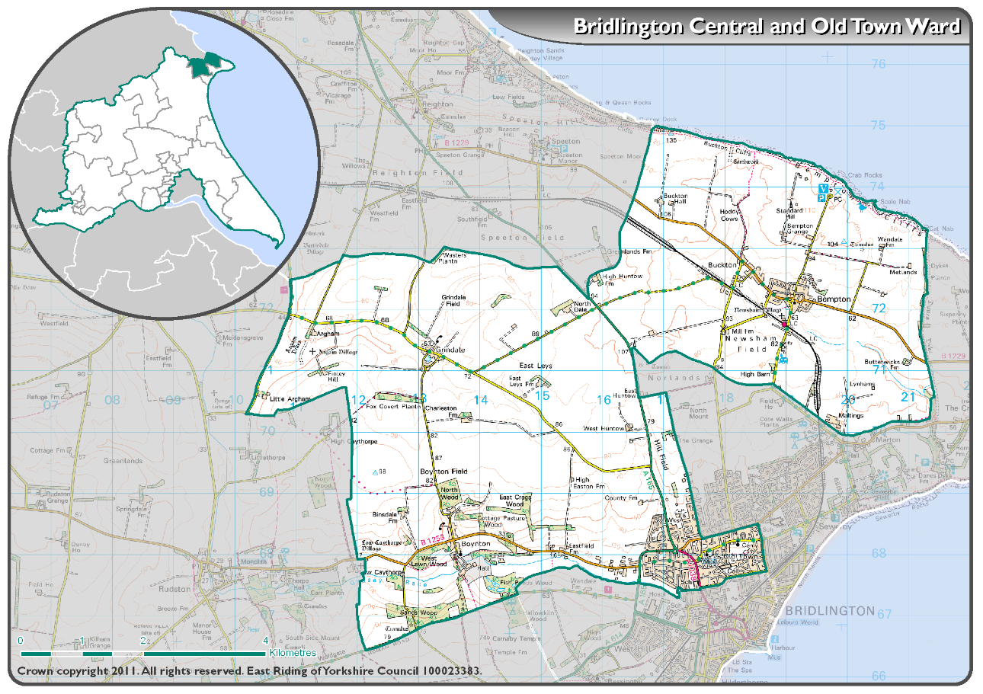AR

AREA COVERED BY BRIDLINGTON NORTH WARD

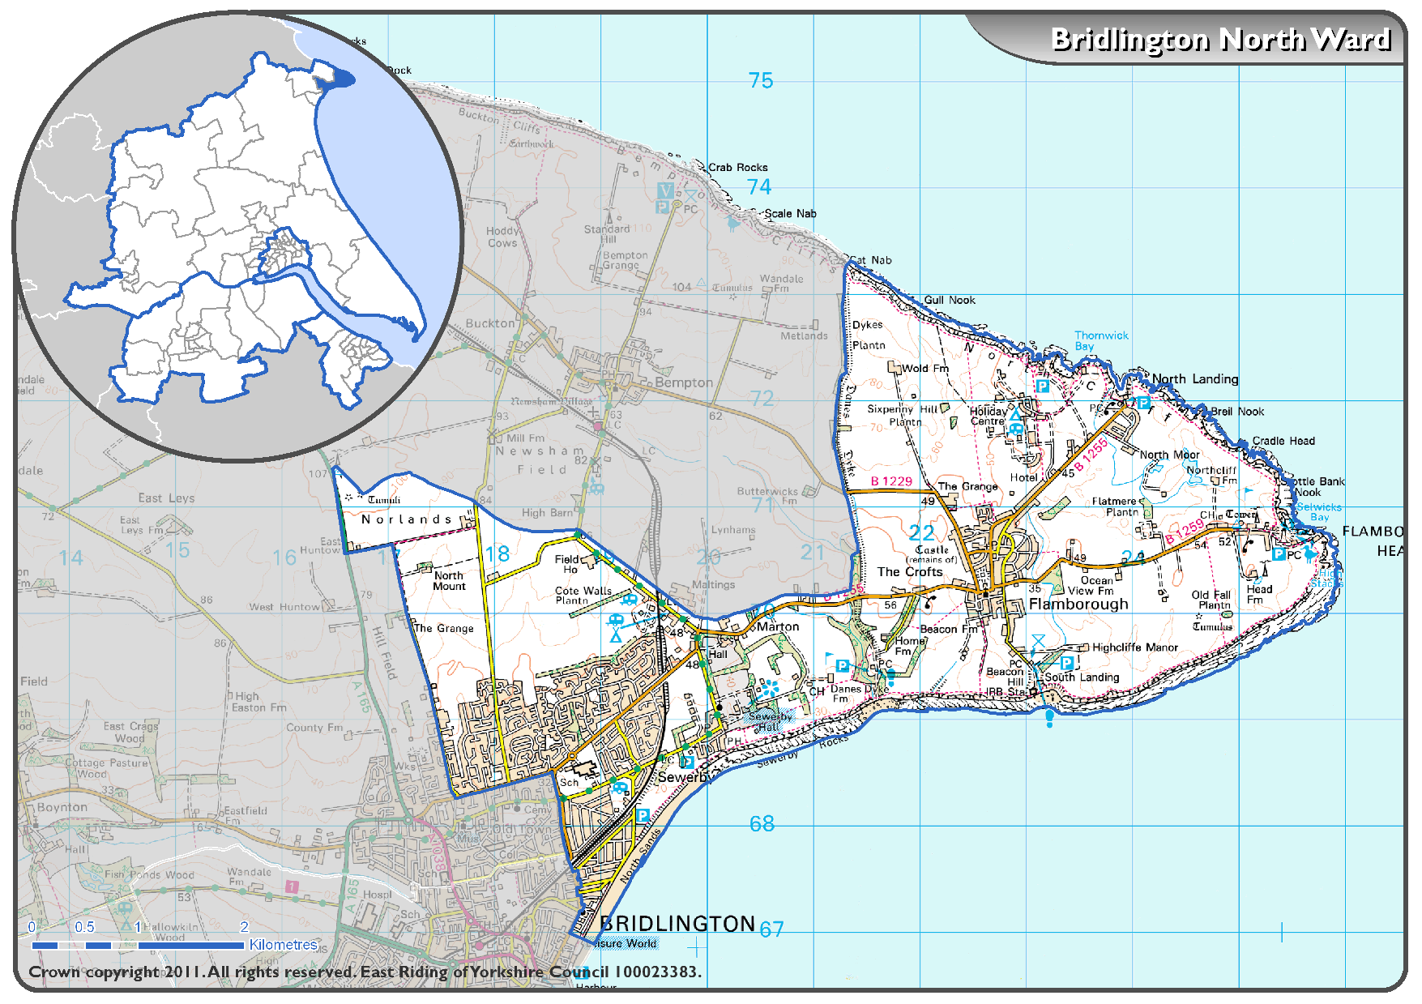

AREA COVERED BY BRIDLINGTON SOUTH WARD

